 | 26.9.16 Editors - Properties Editor - Modifiers Properties Tab - Lattice - Deform Modifiers
Table of content
Curve&Text - Physics modifiers 1
Soft body 1

Lattice - Physics modifiers



Soft body
The Soft body modifier gets added into the modifier stack when you add a Soft Body physics in the Physics tab. It enables Soft Body simulation for the mesh.
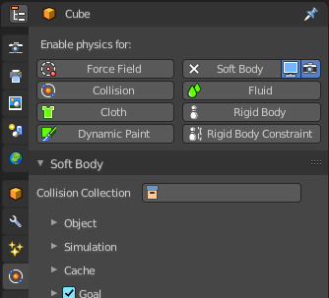
All the Soft body settings and adjustments happens in the Physics tab. The Soft body modifier has no further settings.

